Scholarship
1.problem:
University scholarship Allocation :Design a system that evalutes applicants us subject-wise minimum score, attendance, and ranks eligible students and resolves ties us.
2.Objectives:
To evalute applicants based on four criteria.To filter only eligible students who satisfy all criteria.To rank eligible students by aggregate marks in descending order.To resolve tie aggregate by using attendance percentage
3.Assumptions.
1.Aggregate marks are in percentage (0-100).Minimum required is 80%.Two subjects minimum 40 marks each is required to pass. Attendence minimum 75% is required.Family annual income maximum Rs.2,00,000 is allowed.If no student is eligible, system prints “No eligible students”.
4.Algorithm.
Start
Input number of applicants n
Create empty lists for name,aggregate,subject-pass,attendance,income
For i=0 to n-1:
Input name,aggregate,sub1,sub2,attendance,income.
If sub1>=40 and sub2>=40 then subject -pass=true else false store all in lists.
Create empty eligible lists.
For i=o to n-1:
Add to the eligible list
Sort eligible lists by aggregate disc using bubble sort. If aggregate equal then sort by attendance disc
Print the ranked list
End
5.pseudo code.
Read n
Names=[],agg=[],att=[],inc=[],sub-pass=[]
For I in to n-1
Read name,aggregate,sub1,sub2,attendance,income append to lists
If sub1>=40 and sub2>=40 then sub-pass[i]=true else false
For I in 0 to n-1
If agg[i] >=80 and sub-pass[i]==true and att[i]>=75 and inc[i]<=200000 append to eligible lists.
Print(“Ranked lists”)
For I in to o to len (eligible_names)-1
Print Rank i+1,eligible_names[i],eligible_agg[i],eligible_att[i]
End
6.Test cases:

Ravi | 85 | 45 | 1300
seeta | 90 | 45 | 6700
Rank1
Seeta-eligible
Rank2
Ravi-not eligible

7.Flow chart:
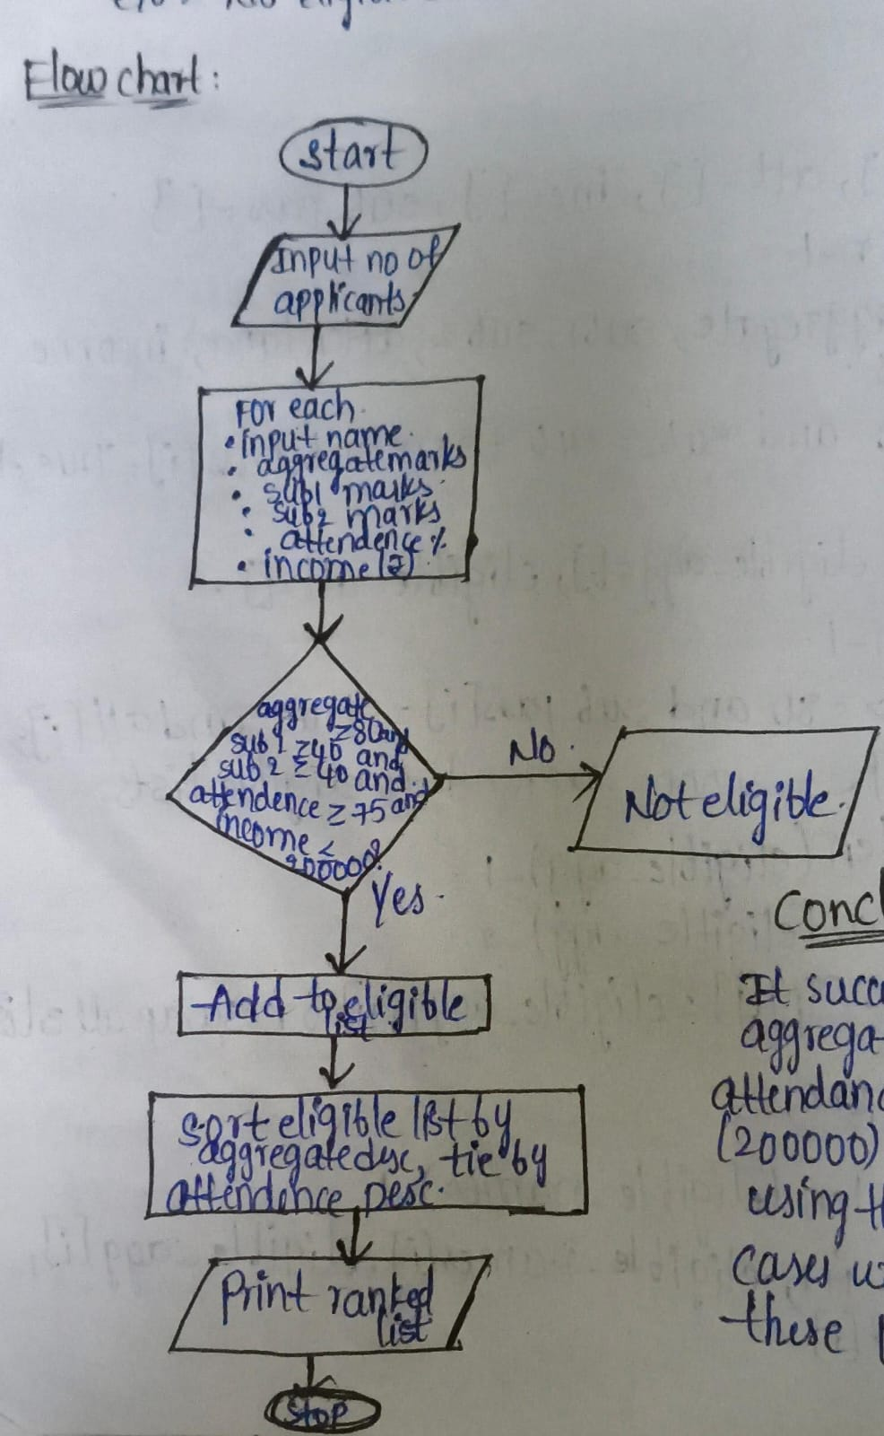
8.code:
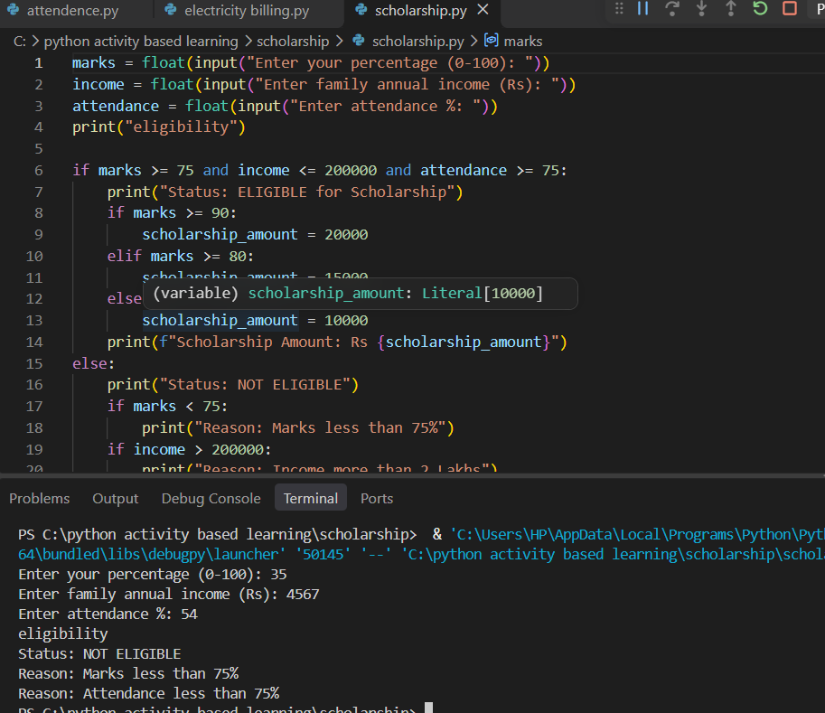
9.Conclusion:
It successfully eligible applicants by aggregate , income ,attendance and all test cases are passed.

